 ***เอกสารส่งเวชระเบียน

สติกเกอร์ชื่อผู้ป่วย
CAG Data Form ห้องสวนหัวใจ โรงพยาบาลพญาไทศรีราชา
A. General information
HCODE 11855 PID ……………………………… วัน/เดือน/ปีเกิด ...........................................................................
เพศ : ชาย หญิง Race ………………(**Admission Date …………..….... **** โปรดระวัง check กับ ระบบให้ตรงกัน*** )
B. History and risk factors (Before CAG visit)
Height ………………… cm. Weight ………………… kg. BMI …………………
Cerebrovascular disease No Yes
Peripheral arterial disease No Yes
Hypertension No Yes
Dyslipidemia No Yes LDL ………….. mg/dl HDL ………….. mg/dl
DM No Yes
Current/ Recent (< 2 year) smoker include electrical cigarette No Yes
Prior MI No Yes
Aortic disease No Yes
Familial Hx of premature CVD No Yes
C. Clinical indication
C1 chronic coronary artery syndromes (CCS)
1. Which group of CCS (choose only one)
suspicious CAD, stable syntromes, either with angina or dyspnea
new onset HF or LV dysfunction, suspicious CAD asymptomatic and symptomatic patients with stabilized symptoms < 1 year after an ACS, or patients with recent revascularization
asymptomatic and symptomatic patients > 1 year after initial diagnosis or revascularization
angina suspicious from vasospasm or microvascular CAD
no symptom but diagnose of CAD from screening
2. Indicaton for CAG in CCS (stable CAD)
Improve symptoms (medically refractory)
Antiplatelet ………………………………………………………… P2Y12I ………………………………………………………………… Beta blocker ……………………………………………………….. Calcium antagonist ……………………………………………… Nitrate ………………………………………………………………... Statin …………………………………………………………………… Ezetimibe ……………………………………………………………. PCSK9 inhibitors ………………………………………………….. ACEI ……………………………………………………………………. ARB ……………………………………………………………………… Ranolazine ………………………………………………………….. Trimetazidine ………………………………………………………. Other ………………………………………………………………………………………………………………………………………………………………..
Improve survival (high risk characters)
heart failure within 2 wks
low EF: <35% 36-50% >50%
+ve EST (angina, STE/STD, hypotension) within 5 mets or low workload
large ischemic area from non-invasive imaging
echocardiogram MRI others (specify) ………………….
Having Hx of VT/VF either at rest or EST
3. Indication for PCI in CCS case
CCS with angina but no anatomic or physiologic criteria for revascularization. -> not recommend
CCS with normal LVF but had 1 or 2 CAD without significant proximal LAD stenosis. -> not recommend
CCS with ≥1 CAD with no anatomical (<70% non LM or non-functional significant (FFR > 0.8) -> not recommend
CCS with normal LVF but had significant proximal LAD stenosis, suitable anatomy
CCS with sig. 3-vv CAD, normal LVF -> CABG (No benefit for PCI)
CCS with multi-vv CAD with moderate LV systolic dysfunction, LVEF 35-50% -> CABG
CCS with selected sig. left main stenosis when PCI can provide resonable equivalent risk/result to CABG
CCS with significant left main stenosis, high anatomic complex CAD, CABG candidate -> CABG
CCS with multi-vessel CAD with severe LV systolic dysfunction, LVEF < 35% -> CABG
CCS with angina but optimal Rx is unclear -> consult heart team
Result medical Rx PCI CABG
C2 Non-ST elevation acute coronary artery syndromes (NSTE-ACS)
1. Diagnostic key
Having ischemic pain Yes No (เป็นส่วน optional ที่ไม่จำเป็นต้องกรอก)คำจำกัดความในตาราง
Having ischemic ECG Yes No
Biomarker elevation Yes ( 1st 2nd ) neg not done
R/O other causes of non-ACS Yes No (เป็นส่วน optional ที่ไม่จำเป็นต้องกรอก)คำจำกัดความในตาราง
LVEF <35% 36-50% >50%
2. Risk stratification
Very high : shock/HF hypotension VT/VF เลือกได้มากว่า 1 ข้อ
High Grace risk score > 140
Intermediate to low Grace risk score < 140
3. CAG & Revascularization guideline for NSTE-ACS
NSTE-ACS case with cardiogenic shock, routine multivessel PCI of non-culprit lesions in the same setting. Should not be performed.
NSTE-ACS cases who have failed PCI and have ongoing ischemia, hemodynamic compromise, or threatened occlusion of an artery with substantial myocardium at risk. Who are appropriate candidates for CABG, emergency CABG is resonable
NSTE-ACS case who are initially stabilized with intermediate or low risk of clinical events, CAG with intent to perform revascularization is reasonable before hospital discharge to improve outcomes.
NSTE-ACS case who are intially stabilized with high risk of clinical events, early (< 24 hrs) CAG is reasonable rather than delayed CAG to improve outcomes.
NSTE-ACS case with refractory angina or hemodynamic or electrical instability, an immediate CAG with intent for revascularization in indicated to improve outcomes.
NSTE-ACS with cardiogenic shock emergent CAG and revascularization, is recommended to reduce risk of death.
NSTE-ACS case with elevated risk of recurrent ischemic events and appropriate candidates for revascularization, CAG with the intent to proceed with revascularization is indicated to reduce cardiovascular events.

C3 ST elevation acute coronary artery syndromes (STE-ACS)
1. Diagnostic key
Ischemic pain Yes No (เป็นส่วน optional ที่ไม่จำเป็นต้องกรอก)คำจำกัดความในตาราง
ECG STE anterior lateral inferior RV (V3R, V4R)
Biomarker elevation Yes ( 1st 2nd ) neg not done
R/O other diseases aortic dissection pulmonary emboli myopericarditis
stress induce cardiomyopathy
2. Risk stratifying
Very high risk
cardiogenic shock VT/VF arrest 3rd degree AV block trifasicular
High risk
hypotension pulm. edema 2nd degree AV block (Mobitz II)
Intermediate
HF no pulm. edema
Low risk
V/S stable no HF STE normalize
3. Initial dicision for reperfusion
PCI if First Medical Contact (FMC) diagnosis to wire crossing < 120 min
FMC diagnosis to wire crossing > 120 min, thrombolysis*** first, and refer to PCI center
R/O severe allergic reaction to contrast media, thrombolysis*** first
PCI if very high-high risk
PCI if allergic to thrombolytic agent
PCI if having contra-indication for thrombolytic agent
Rescue PCI if failed thrombolytic agent

4. Revascularization guideline in STE-ACS case
ischemic symptoms for < 12 hours, PCI should be performed to improve survival
cardiogenic shock or hemodynamic instability, PCI or CABG (when PCI is not feasible) is indicated to improve survival, irrespective of the time delay from MI onset.
mechanical complications (e.g. ventricular septal rupture, mitral valve insufficiency from papillary muscle infarction or rupture, or free wall rupture), CABG is recommended at the time of surgery, with the goal of improving survival.
evidence of failed reperfusion after fibrinolytic therapy, rescue PCI of the infarct artery should be performed to improve clinical outcomes.
treated with fibrinolytic therapy, angiography within 3 to 24 hours with the intent to perform PCI is reasonable to improve outcomes.
stable and presenting 12 to 24 hours after symptom onset, PCI is reasonable to improve clinical outcomes.
PCI is not feasible or successful, with a large area of myocardium at risk, emergency or urgent CABG can be effective as a reperfusion modality to improve clinical outcomes.
complicated by ongoing ischemia, acute severe heart failure, or life-threatening arrhythmia, PCI can be beneficial to improve clinical outcomes, irrespective of time delay from MI onset
Asymptomatic stable STEMI case who have a totally occluded infarct artery > 24 hours after symptom onset and are without evidence of severe ischemia. PCI should not be performed
PCI of non-infarct A is not recommended (harmful) in cardiogenic shock case
STEMI case, emergency CABG should not be performed after failed primary PCI: In the absence of ischemia or a large area of myocardium at risk, or If surgical revascularization is not feasible because of a no-reflow state or poor distal targets.

C4 Cardiomyopathy (CMP)/ Congestive heart failure (CHF)
1. Definition: Disorder of heart muscle (structurally and functionally abnormal) in the absence (CAD), hypertension, valve disease, and congenital heart disease (CHD)
2. Type
Dilated CMP: LV dilatation with global or regional systolic dysfunction unexplained solely by abnormal loading conditions (e.g. hypertension disease, CHD) or CAD
Hypertrophic CMP
Restrictive CMP
Stress induced CMP (Takotsubo syndrome)
Arrhythmogenic RV CMP
Other ………………………………………………………
3. Investigation
Ischemic ECG : Yes No not done
Echocardiogram
LVEF < 35% 35-50% > 50% not done (เป็นส่วน optional จะกรอกหรือไม่กรอกก็ได้)
MRI normal abnormal not done
EST ischemia at low work load Yes No เลือก 1ข้อ ( VT/VF not done เลือก 1ข้อ)
CTA Yes not done
4. If CAG was performed, what do you plan next, according to current guideline
No Yes (result below) Consult heart team*
Medical Rx CABG
PCI

C5 Pre-operative assessment of CAD
1. Diagnosis
Hx of CAD Yes (specify) ………………………… No
Valvular heart disease AVS/AVR MVS/MVR TVS/TVR PVS/PVR
Congenital HD ASD VSD others …………………………….
Pre-post cardiac transplant
2. Investigation
Ischemic ECG: Yes No not done
Echocardiogram
LVEF < 35% 35-50% > 50% not done (เป็นส่วน optional จะกรอกหรือไม่กรอกก็ได้)
MRI normal abnormal not done
EST ischemia at low work load Yes No เลือก 1ข้อ ( VT/VF not done เลือก 1ข้อ )
CTA Yes not done
3. If CAG was performed, what do yor plan next, according to current guideline?
No Yes (result below) Consult heart team*
Medical Rx CABG
PCI

C6 Post cardiac arrest
1. STE (เป็นส่วน optional จะกรอกหรือไม่กรอกก็ได้)
With STE Without STE
Among patients with resuscitated out-of-hospital cardiac arrest without ST-segment elevation, a strategy of performing immediate angiography no benefit over a delayed or selective strategy with respect to the 30-day risk of death from any cause
2. If CAG was performed, what do you plan next, according to current guideline? (เป็นส่วน optional จะกรอกหรือไม่กรอกก็ได้)
Consult heart team* No Yes (result below)
Medical Rx
CABG
PCI

I. CAG Procedure, findings and complications
Date of CAG ……………………………………………( มากกว่าหรือเท่ากับวัน admission date )
Pre-CAG Risk very high (OR > 3) high (OR 2-3) intermediate (OR 1-2) low OR ≤ 1
Risk reduction intervention before CAG Yes No
Responsible Physician : Name …………………………………………… MD licence N. ว. …………………………………………..
Filler person : Physician Name …………………………………………… RN/ Technician name …………………………………..
Access site : femoral radial brachial other …………………………………………………. เลือก 1 ข้อ
Lesions : 1-vv CAD 2-vv CAD 3-vv CAD LM disease non obstructive coronary artery
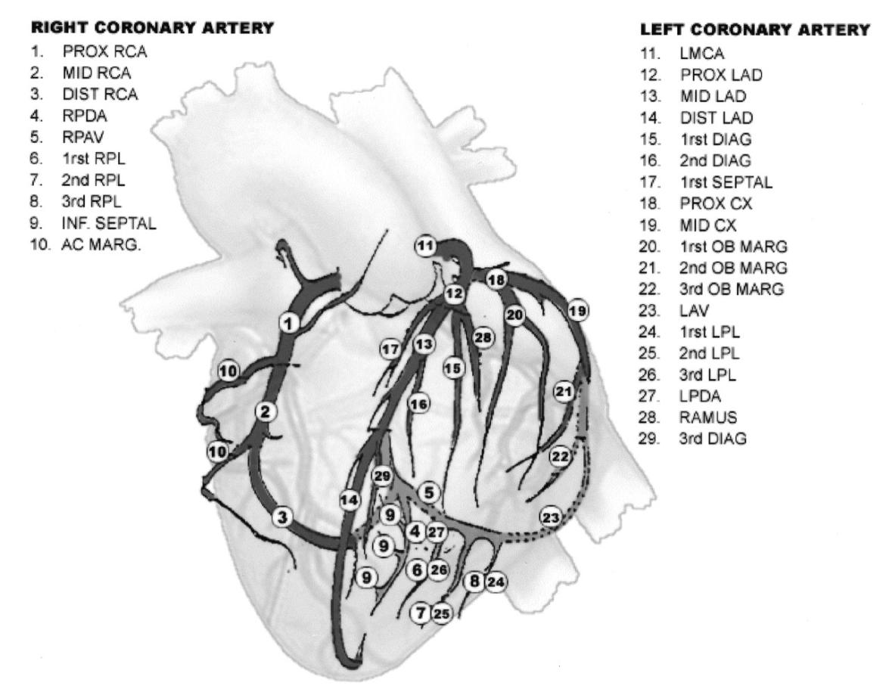

Location No. (from figure) (เป็นส่วน optional จะกรอกหรือไม่กรอกก็ได้)
% stenosis * Gensini range 1-25% 26-50% 51-75% 76-90% 91-99% 100%
% stenosis * Gensini range 1-25% 26-50% 51-75% 76-90% 91-99% 100%
% stenosis * Gensini range 1-25% 26-50% 51-75% 76-90% 91-99% 100%
% stenosis * Gensini range 1-25% 26-50% 51-75% 76-90% 91-99% 100%
% stenosis * Gensini range 1-25% 26-50% 51-75% 76-90% 91-99% 100%

Complications : No Yes
death after CAG < 24 hrs > 24 hrs
stroke after CAG < 24 hrs > 24 hrs
ARF after CAG < 24 hrs > 24 hrs
Creatinine before CAG ……….. mg/dl after CAG ………… mg/dl require dialysis
allergic reaction anaphylaxis not severe
hematoma < 24 hrs > 24 hrs blood transfusion
perforation (site ……………………………………………….….)
dissection (site …………………………………………………….)
ACS STE NSTE เลือก 1 ข้อ (เป็นส่วน optional จะกรอกหรือไม่กรอกก็ได้)
shock cardiogenic hypovolemic เลือก 1 ข้อ
bradycardic arrest VT/VF AVB เลือก 1 ข้อ
bleeding intra-peritoneal GI blood transfusion
other ………………………………………………………………

II. PCI Procedure, findings and complications
Date of PCI ……………………………………………( มากกว่าหรือเท่ากับวัน admission date )
Pre-CAG Risk very high (OR > 3) high (OR 2-3) intermediate (OR 1-2) low OR ≤ 1
Risk reduction intervention before CAG Yes No
Responsible Physician : Name …………………………………………… MD licence N. ว. …………………………………………..
Filler person : Physician Name …………………………………………… RN/ Technician name …………………………………..
Access site : femoral radial brachial other …………………………………………… เลือก 1 ข้อ

1. Target artery
LM segment No …………………..
Previous PCI No Yes, if yes segment No. …………………………
Stent No Yes, specify: BMS DES
Implanted date ………………………………………….
In Stent Restenosis (ISR) thrombosis
Baseline stenosis Gensini rang: 1-25% 26-50% 51-75% 76-90% 91-99% 100%
By: visual estimate QCA (e-calipper)
Lesions types type A type B1 type B2 type C
Pre-PCI TIMI TIMI-0 TIMI-1 TIMI-2 TIMI-3
SYNTAX Score low SYNTAX (0-22) Intermediate SYNTAX (23-32) high SYNTAX (>33)
Stent use No Yes, specify: ชื่อ stent.+ size............................................................….……... BMS DES
Final stenosis Gensini range : 1-25% 26-50% 51-75% 76-90% 91-99% 100% By: visual estimate QCA (e-calipper)
Final TIMI TIMI-0 TIMI-1 TIMI-2 TIMI-3

LAD/DG segment No …………………..
Previous PCI No Yes, if yes segment No. …………………………
Stent No Yes, specify: BMS DES
Implanted date ………………………………………….
In Stent Restenosis (ISR) thrombosis
Baseline stenosis Gensini rang: 1-25% 26-50% 51-75% 76-90% 91-99% 100%
By: visual estimate QCA (e-calipper)
Lesions types type A type B1 type B2 type C
Pre-PCI TIMI TIMI-0 TIMI-1 TIMI-2 TIMI-3
Stent use No Yes, specify: ชื่อ stent.+ size............................................................….……….. BMS DES
Final stenosis Gensini range : 1-25% 26-50% 51-75% 76-90% 91-99% 100% By: visual estimate QCA (e-calipper)
Final TIMI TIMI-0 TIMI-1 TIMI-2 TIMI-3

Cx/OM segment No …………………..
Previous PCI No Yes, if yes segment No. …………………………
Stent No Yes, specify: BMS DES
Implanted date ………………………………………….
In Stent Restenosis (ISR) thrombosis
Baseline stenosis Gensini rang: 1-25% 26-50% 51-75% 76-90% 91-99% 100%
By: visual estimate QCA (e-calipper)
Lesions types type A type B1 type B2 type C
Pre-PCI TIMI TIMI-0 TIMI-1 TIMI-2 TIMI-3
Stent use No Yes, specify: ชื่อ stent.+ size............................................................….……….. BMS DES Final stenosis Gensini range : 1-25% 26-50% 51-75% 76-90% 91-99% 100% By: visual estimate QCA (e-calipper)
Final TIMI TIMI-0 TIMI-1 TIMI-2 TIMI-3

Trifurcation segment No …………………..
Previous PCI No Yes, if yes segment No. …………………………
Stent No Yes, specify: BMS DES
Implanted date ………………………………………….
In Stent Restenosis (ISR) thrombosis
Baseline stenosis Gensini rang: 1-25% 26-50% 51-75% 76-90% 91-99% 100%
By: visual estimate QCA (e-calipper)
Lesions types type A type B1 type B2 type C
Pre-PCI TIMI TIMI-0 TIMI-1 TIMI-2 TIMI-3
Stent use No Yes, specify: ชื่อ stent.+ size............................................................….…………. BMS DES Final stenosis Gensini range : 1-25% 26-50% 51-75% 76-90% 91-99% 100% By: visual estimate QCA (e-calipper)
Final TIMI TIMI-0 TIMI-1 TIMI-2 TIMI-3

RCA/PDA segment No …………………..
Previous PCI No Yes, if yes segment No. …………………………
Stent No Yes, specify: BMS DES
Implanted date ………………………………………….
In Stent Restenosis (ISR) thrombosis
Baseline stenosis Gensini rang: 1-25% 26-50% 51-75% 76-90% 91-99% 100%
By: visual estimate QCA (e-calipper)
Lesions types type A type B1 type B2 type C
Pre-PCI TIMI TIMI-0 TIMI-1 TIMI-2 TIMI-3
Stent use No Yes, specify: ชื่อ stent.+ size............................................................….……….. BMS DES Final stenosis Gensini range : 1-25% 26-50% 51-75% 76-90% 91-99% 100% By: visual estimate QCA (e-calipper)
Final TIMI TIMI-0 TIMI-1 TIMI-2 TIMI-3

2. Complications : No Yes
death after PCI < 24 hrs > 24 hrs
stroke after PCI < 24 hrs > 24 hrs
ARF after PCI < 24 hrs > 24 hrs
Creatinine before PCI ……….. mg/dl after PCI ………… mg/dl require dialysis
hematoma < 24 hrs > 24 hrs need blood transfusion
perforation (site ……………………………………………….….)
dissection (site …………………………………………………….)
no reflow ACS ( STE NSTE )เลือกข้อใดข้อหนึ่ง
shock cardiogenic hypovolemic
bradycardic arrest VT/VF AVB เลือกข้อใดข้อหนึ่ง

